Experiment-3
Student Name:Raj Kumar Singh UID: 23BCS11393
Branch: CSE Section/Group: KRG-3B
Semester: 6th Date of Performance: 28/01/26
Subject Name: System Design Subject Code: 23CSH-314

- AIM : To design a social media platfrom similar to Facebook or Instagram

- Objective:
• To design and develop a scalable social media application that allows users to register, connect, and interact through posts.
• To provide core social networking features such as posting, following, liking, commenting, and feed generation.
• To ensure high availability and low latency, making the application accessible to a large number of users at all times.
• To design RESTful APIs that efficiently handle user onboarding, content management, and user interactions.

- Tools Required:
• Frontend: HTML, CSS, JavaScript, React.js
• Backend: Node.js, Express.js
• Database: MongoDB
• API Testing: Postman
• Authentication: JWT
• Media Storage: Cloudinary / AWS S3
• Version Control: Git, GitHub
• Deployment: AWS / Render / Vercel

- SYSTEM DESIGN / SYSTEM SPECIFICATION:
  - Functional Requirements:
- Client should be able to register and login to the application.
- Client should be able to create post (text / image / videos)
- Client should be able to follow each other (or send friend requests).
- Client should be able to like or comment on the post.
- Client should be able to view the feed of post from users they follow.

  - Non-functional Requirements:
- Scalability: 500M daily active users.
- Consistency & Availability: For social media applications, availability is more important than consistency.
If an application is not available or working when users need it, then building such an application has no real value.
For example, if Instagram is down for one hour, it becomes a major problem for users.
However, if Instagram is running and a post takes 500 ms longer to reach followers, it is not a big issue when compared to downtime.
Therefore, in social media systems:
Availability is prioritized over Consistency.
- Latency: (Uploading speed of publishing post): 500ms to upload post

  - Core-Entites of the System:

  - User
  - Posts
  - Followers
  - Like and Comment
  - Feed

  - API Endpoints Creation:
A. User On-boarding API's
    - User Registeration: POST API CALL:POST / api / users / register_user
    - User Login: POST API CALL: POST / api / users / login
    - User Data Display: GET API CALL: GET / api / users / {user_id} / profile
    - User Data Update: PUT API CALL: PUT / api / users / {user_id} / profile

B. User Post's

- POST / api / user_id / posts
- GET / api / posts / {post_id}
- PUT / api / posts / {post_id}
- DELETE / api / posts / {post_id}
- GET / api / posts / feed / limit = {limit} & offset = {offset} : PAGINATION
- GET / api / users / {user_id} / posts: PAGINATION

C. User Interactions
- POST / api / posts / {post_id} / like
- DELETE / api / posts / {post_id} / unlike
- POST / api / posts / {post_id} / comments
- GET / api / posts / {post_id} / comments
- PUT / api / {post_id}/ comments / {comment_id}
- DELETE / api / {post_id}/ comments/ {comment_id}
- POST / api / users / {user_id} / follow
- DELETE / api / users / {user_id} / unfollow

- HLD(High Level Design):

We have to follow a distributed / micro-services approach not the monolithic one.
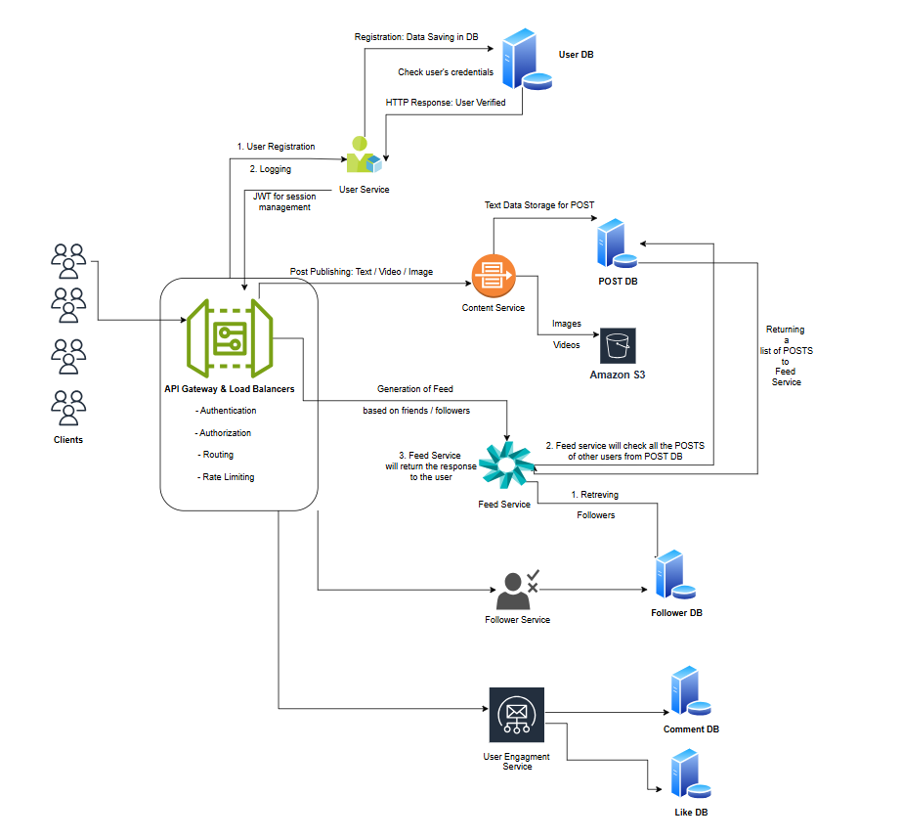


DEPARTMENT OF
COMPUTER SCIENCE & ENGINEERING

- LLD(Low Level Design
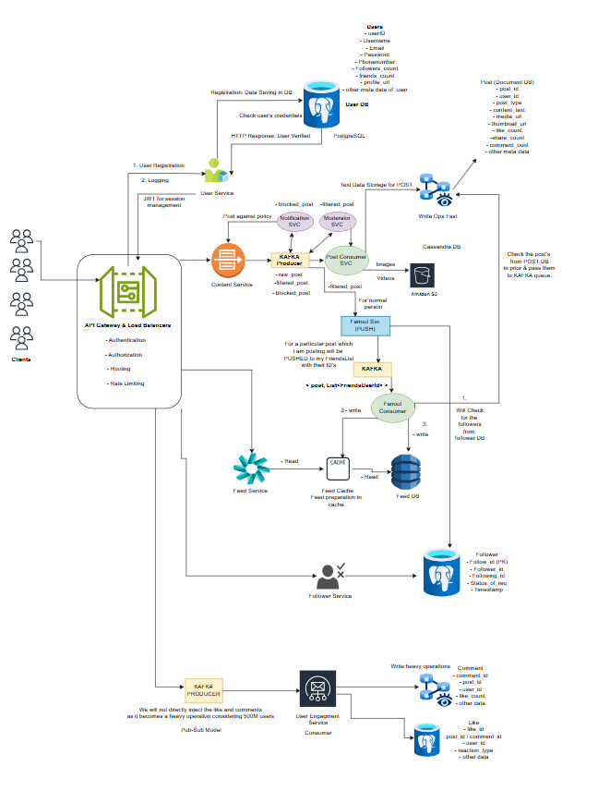

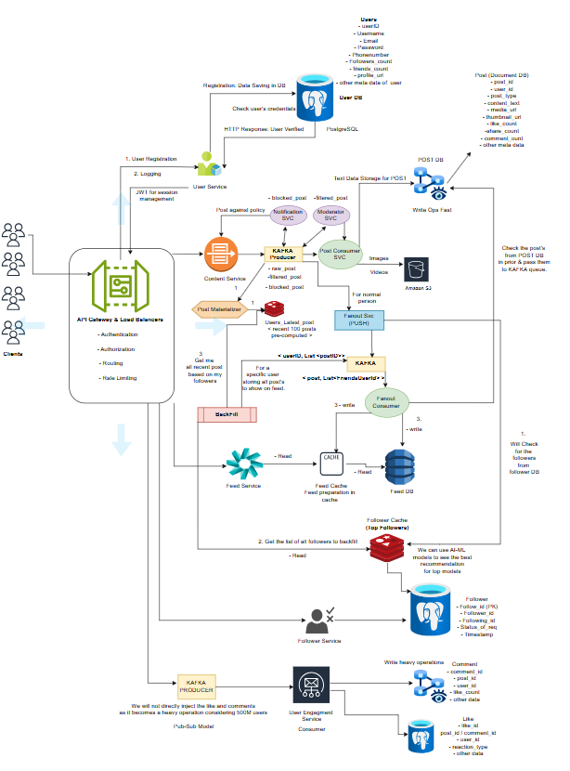

- Learning Outcomes

• Understand and define functional and non-functional requirements of a social media system.
• Design a system that prioritizes availability over consistency as per real-world social media use cases.
• Identify and model core entities such as Users, Posts, Followers, Likes, Comments, and Feed.
• Design RESTful API endpoints for user management, post handling, and social interactions.
• Apply concepts of scalability, latency, and pagination in system design.
• Gain practical exposure to real-world system design considerations used in large-scale applications like Instagram or Facebook.

